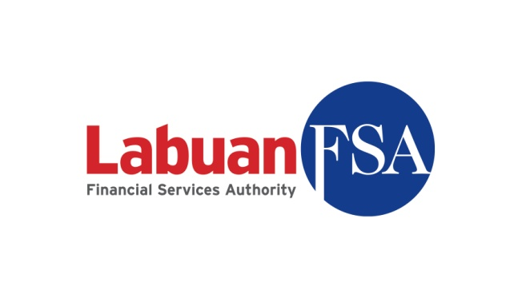

LABUAN FINANCIAL SERVICES AUTHORITY (LABUAN FSA)

Notification on dealing with resident of Malaysia pursuant to
Section 7(5) the Labuan Companies Act 1990.

Name of the  Labuan Company | (LL/LF )
Notification submitted by (if applicable)

Date received by Labuan FSA

Remarks/Comments

- Details of the transaction.
- Rationale and advantages of the transaction using a Labuan company including tax benefits etc.
- Total amount and source of funds in funding the transaction.
- Profile of each companies involve in the proposed transaction
- Labuan company

Name:
Date of incorporation:
Nature of business:
Authorised capital:
Paid-up capital:
Director(s):
Shareholder(s):

Note: Please add if more than one Labuan companies involve

- Beneficial owner of the Labuan company(ies)

Name:
Date of incorporation:
Nature of business:
Authorised capital:
Paid-up capital:
Director(s):
Shareholder(s):

If the beneficial owner is an individual-

Name:
Citizenship:
Identification No./
Passport No.:
Current residential address:

Note: Please add if more than one beneficial owners involve

- Malaysian company(ies)

Name:
Date of incorporation:
Nature of business:
Authorised capital:
Paid-up capital:
Director(s):
Shareholder(s):

Note: Please add if more than one Malaysian companies involve

- Any approval required from relevant regulatory authority including Bank Negara Malaysia, Securities Commission, Foreign Investment Committee (if any) with regard to the proposed transaction/investment, wherever is applicable. What is the status of the application?

The undersigned solemnly and sincerely declare that in relation to the above transaction-

- The relevant vetting has been conducted on the beneficial owner, relevant parties and source of fund of the above transaction.

- The source of fund (if any) of the transaction is not from or for any illegal activities.

- That we have in our possession relevant documents/records on the transaction and subject to the relevant provision of the law related to Labuan IBFC, Labuan FSA or any person authorised by the relevant laws may inspect the documents at any time.

- That all requirements of the Labuan Companies Act 1990 and the regulations, guidelines and directions made thereunder in respect of matters precedent and incidental to the above transaction have been complied with.

................................ ...................................
Signature Date

Name:
(Director of the Labuan Company or Trust Officer)

IMPORTANT NOTE – THE FOLLOWING SHALL FORM AS AN INTERGRAL PART OF THIS NOTIFICATION

PART A

Notwithstanding the above, Labuan FSA reserves the right to impose any condition as it deems fit and necessary on the Labuan company with regard to the transaction herein mentioned.

PART B

If Labuan FSA is of the opinion that the transaction or any information submitted herein-

- require further explanation, clarification or verification;

- contains matter contrary to law;

- contains matter that, in a material particular, is false or misleading in the form or context in which it is included;

- by reason of an omission or misdescription has not been duly completed;

- does not comply with the requirements of any laws; or

- contains an error, alteration or erasure,

Labuan FSA may-

- refuse to accept this notification;

- withdraw the approval to the transaction;

- request that the notification be appropriately amended or completed and re-submitted;

- request that a fresh notification be submitted in its place; or

- request that a supplementary document/information be submitted to verify any information in this notification.

